**EXPERIMENT-4**

**AIM:** To find the wavelength of mercury green light by diffraction grating using spectrometer.

**APPARATUS:** Spectrometer, diffraction grating element and mercury vapor lamp.

**THEORY:**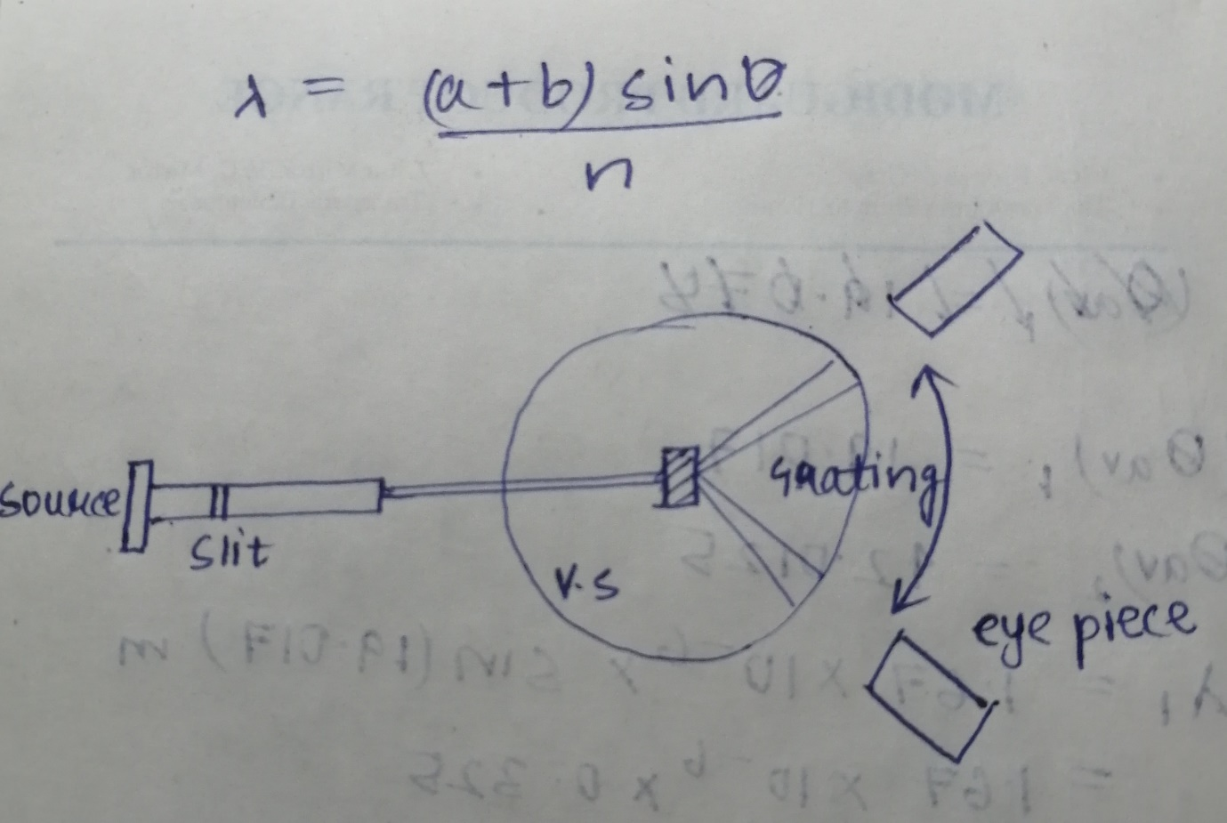

**OBSERVATION:** Least count=1/120 degrees

Grating element (a+b) = 1/600 mm=1.67X10-6m

Wavelength of mercury green light actual=546.1nm

|  |  |  |  |  |  |  |  |  |  |
| --- | --- | --- | --- | --- | --- | --- | --- | --- | --- |
| S. No | Order of diffraction(n) | Left Spectrum | | | | Right Spectrum | | | |
|  |  | MSR | VSR | Total | | MSR | VSR | Total | |
| 1 | 1 | 341 | 5 | | 341.041 | 19 | 9 | | 19.075 |
| 2 | 2 | 315 | 3 | | 315.025 | 39 | 6 | | 39.050 |

**CALCULATION:**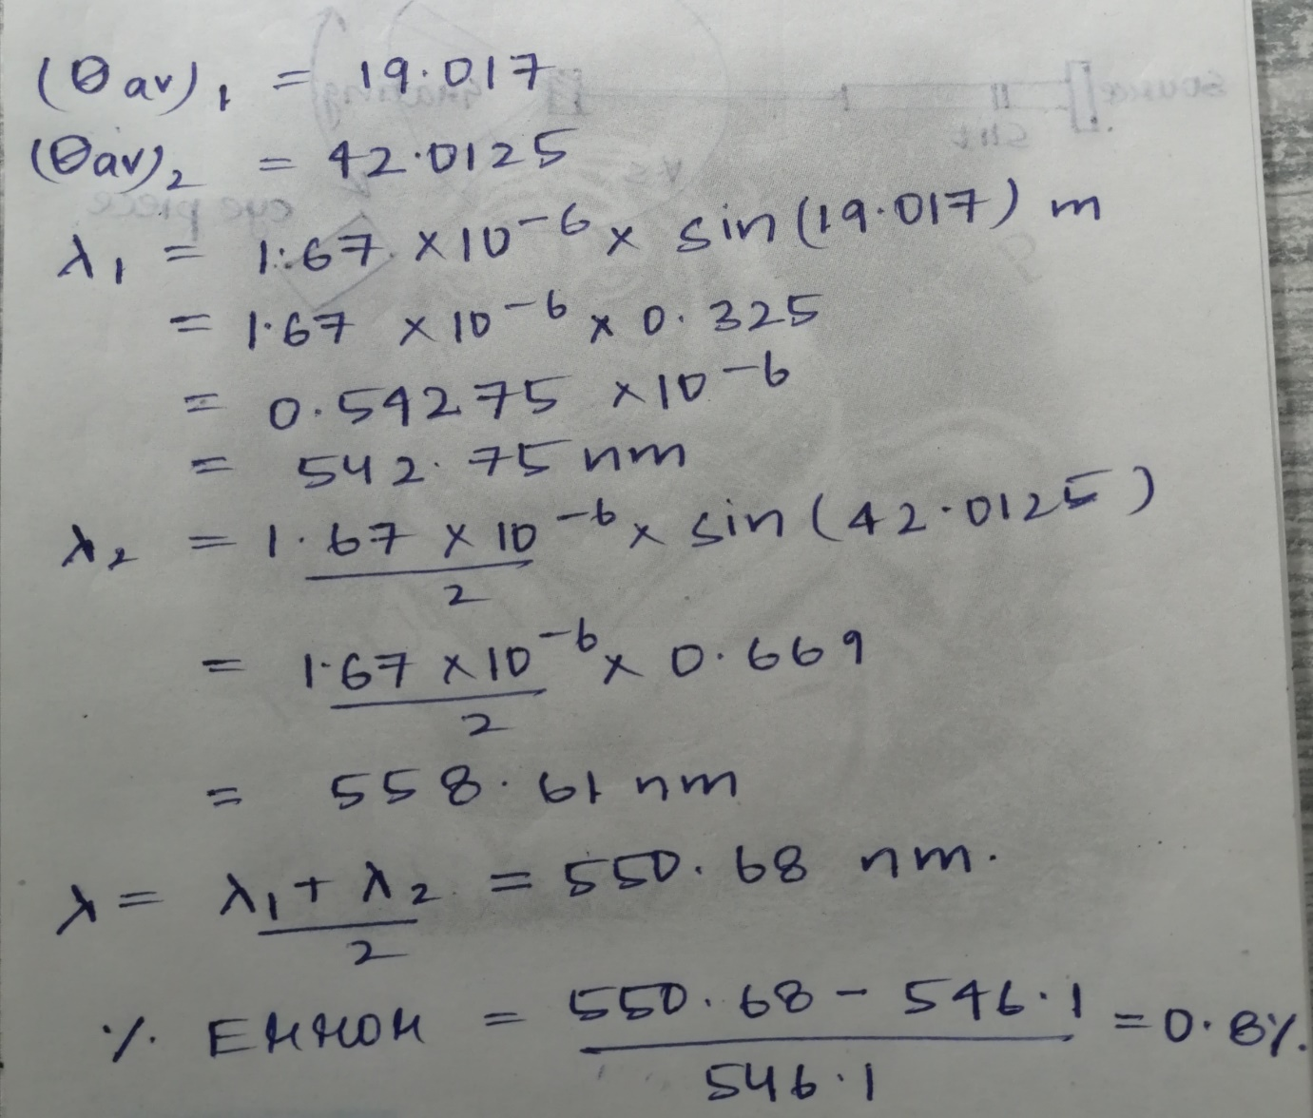

**RESULT:** Wavelength of mercury green light as determined from experiment is 550.68nm.

Percentage error is 0.8%.

**PRECAUTIONS:** 1) The mechanical adjustment of the telescope should be carried.

2) The slit used must be as narrow as possible.

3) Use reading lens while recording the vernier scales.

**By: Amogh Garg**

**2020UCO1688**